Name : Zeshan Sayed.
ID: A20379970.

Description:
It is an Apartment Management System which consist of 2 views (admin /user), where user registers and he is provided an account. User can read personal Info, add complain, view apartment Info and update password. Admin can create/delete/read apartment, create /delete/read lease, read/delete user, create/update/read rent.
Firstly, if user cannot sign in, then first he /she has to register registration is successful then he can log in. It consist of validation at every form so that the fields cannot be left empty.

For Admin:
Username: admin
Password: admin

For User: ( or you can register)
Username:sambu
Password:4321

Specifications:

- CRUD
- USER :
Tables table table table

Operation | z_saye_tenant | z_saye_user | z_saye_complain | z_saye_rent
Create | Create profile  (Register) | Creates Username  (in user table) | Creates Complain  Extra Credit:
Read | Reads Profile  (Views tenant table) | Cannot Read  (user table) | Reads Complain  Extra Credit: | Views Rent  Extra Credit:
Update |  | Updates Password  (updates password)
Delete

Admin: tables

Operations | z_sayed_apartment | z_sayed_lease | z_saye_rent | z_saye_tenanat | z_saye_complain
Create | Creates apartment | Create lease | Create Rent  Extra Credit:
Read | View Apartments | View Lease | View Rent  Extra Credit: | View Tenant  Extra Credit: | View Complains  Extra Credit:
Update |  |  | Update Rent  Extra Credit:
Delete | Delete Apartments | Delete Lease |  | Delete Tenant  Extra Credit:

- Coding Architecture

Architecture of coding:

- Code is organized in MVC model.
- The application consist of Main and Call files which calls my FXMl pages.
- All Controllers of FXML pages are saved in respective Controller Package.
- All Model files are saved in respective Model Package.
- All Dao files are organized in respective Dao Package

None of you class attributes must be static: Two static attributes are used to check the username and password of the person who has logged in, in order to change password.

All of your class attributes must be private and accessed / modified using getter / setter methods :.Condition Satisfied.

Inheritance : Inheritance is used in calling dialogue stage for 2 Controllers. Also it can be used for calling many controllers but 2 subclasses is enough. The dialogueStage used in application acts as a parent class for AdminController and ApartmentController.

- Login
Login page is the first page. If the user is not logged in then the application request users for registration .User registers and then he can login.

- Navigating through your related Entities
- Change password function relates entities and operation while the user is logged in.
- User can view its personal information.
- User can view rent information.

- DAO layer

- Dao files created for every entity on which CRUD operations are perfomed.
- There are 6 Dao files with different Dao opeartions.

- DRY principle
Dry principle is tried to obtain the fullest as using Connector File for Creating Connections and not passing values each time.

- Validation and Exception handling
Validation is obtained on every page:
- Login page for verifying existing users and cannot be kept empty.
- Registration page is validated and cannot be kept empty, also the Email should contain special characters and password and confirm password should be same or else it is prompted.
- Empty fields are checked on every input page.

- GUI
GUI is kept simple and easy to understand .It consist of 2 views, User and Admin, User and admin both are greeted, also every page consist of logout button and cancel button if user makes a mistake.

Turn in your entire app into BB packaged as follows:

All source project files into a zip.
Include relevant, not overly done snapshots into a Word doc file labeled accordingly. Include a brief description of your app as well for starters including your name/section number. Also please let us know your login credentials to test your app. A nice idea also may include a video link of your app. Please visit http://www.techsmith.com/jing,html for the download.

A jar file of your executable app.

Screenshots:

Login :

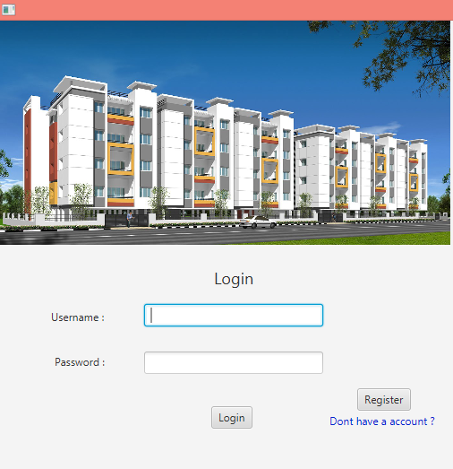

Username and password cannot be kept blank:

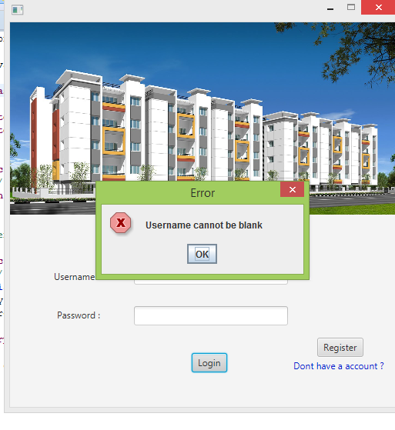
Invalid username pass not present in database:
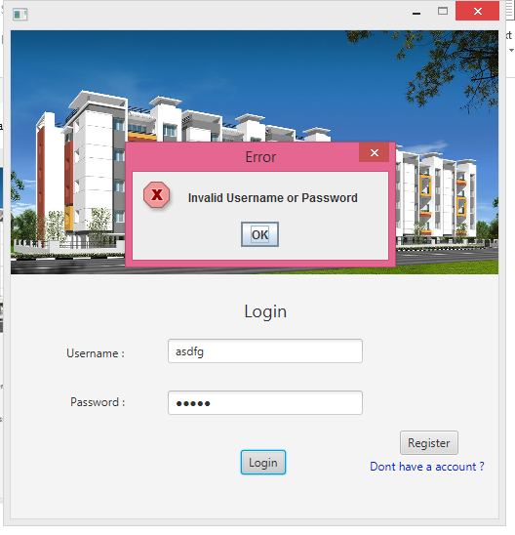

valid User login:
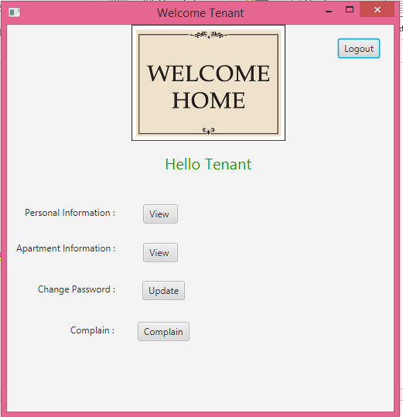

View personal information:
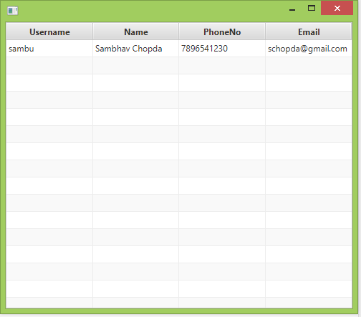

Change password:
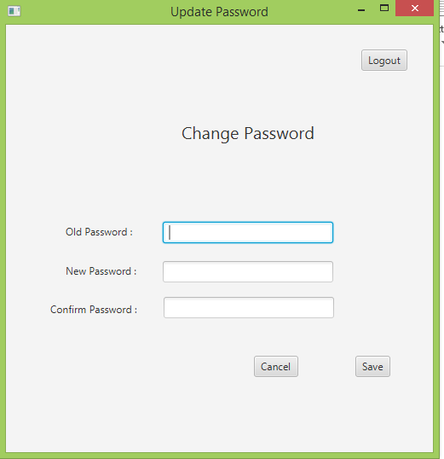

Add Complain:
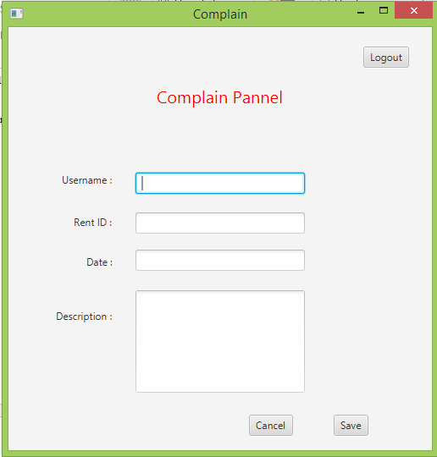

Admin login:
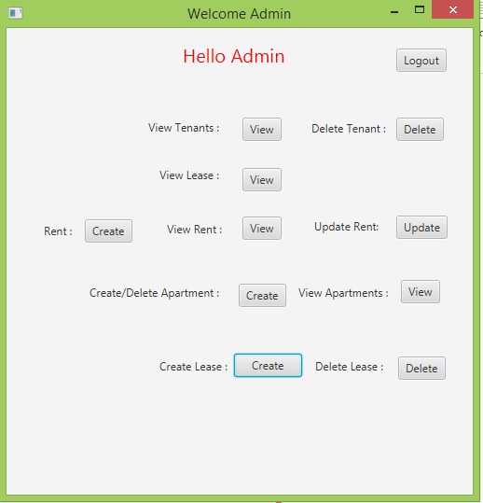

Admin can view Tenant
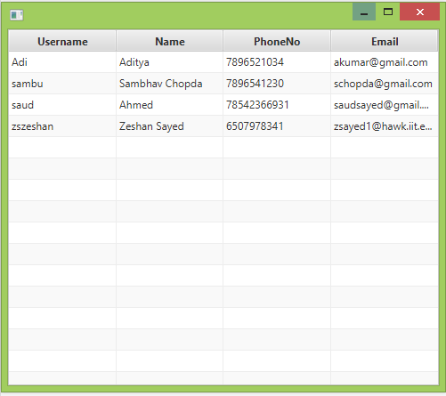

Admin Can view Lease :
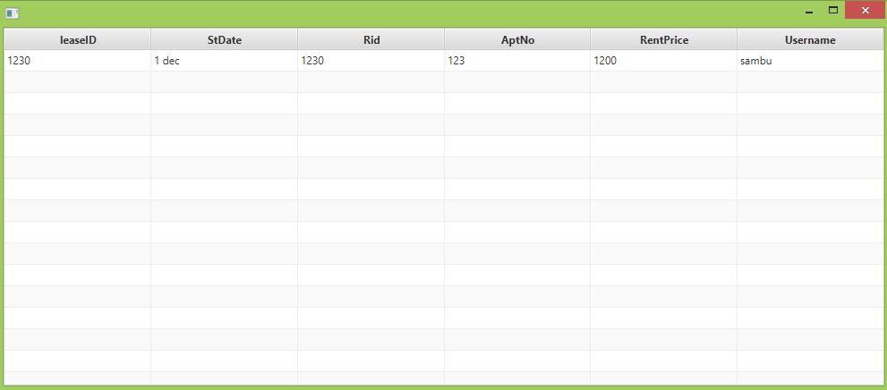

Admin can view and update Rent:
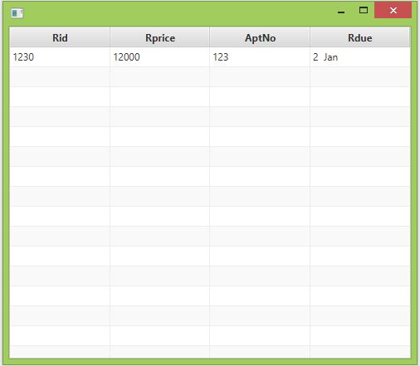

Admin Creates Apartment:
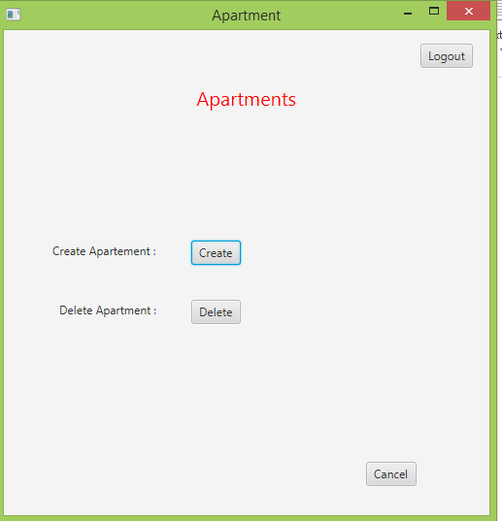

Admin Deletes Apartment:
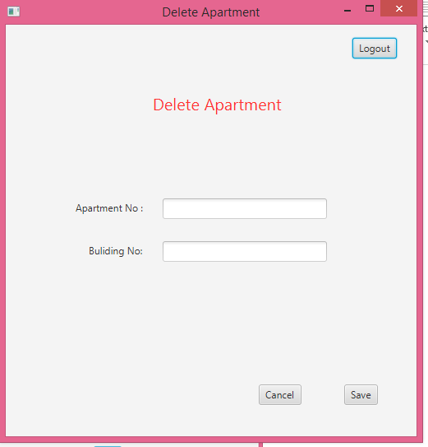

Admin views Apartment:
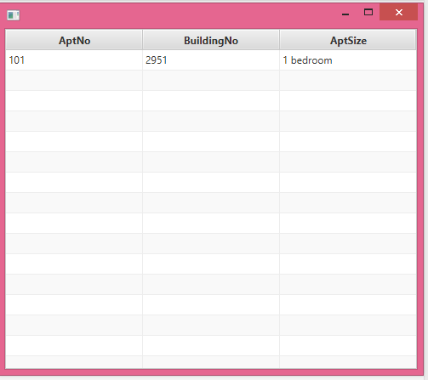

Admin Deletes Apartment:
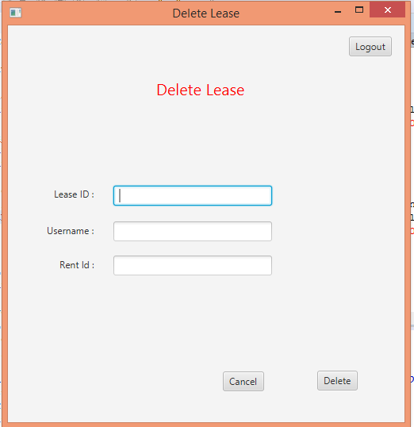
Admin Creates Lease :
